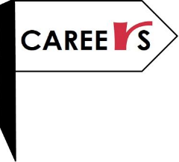2019 Roundwood Park Professional Placement Programme
Another successful year of work experience for our Year 12 students. It can feel like a daunting prospect; contacting employers and heading out to a work place, but our students did fantastically well with some great ‘win’s’ for themselves personally and professionally.
A couple of our budding journalists, Isobel Wellsbury and Charlotte Bateman both successfully saw their articles published in the respective newspapers they ‘interned’ with whilst another student secured sponsorship to undertake a degree. Many exciting opportunities were undertaken with some fantastic companies such as Leidos, Airbus, Santander, Houses of Parliament and many more.
I’d like to thank the students for being so professional and representing the school impeccably.
The feedback from employers was incredible and all said that our students were a credit to the school and the support of parents, carers and guardians.
I’d also like to thank the sixth form tutors for being such a crucial support to a successful placement programme this year.
Read for yourselves the benefits of undertaking work experience from our feedback.
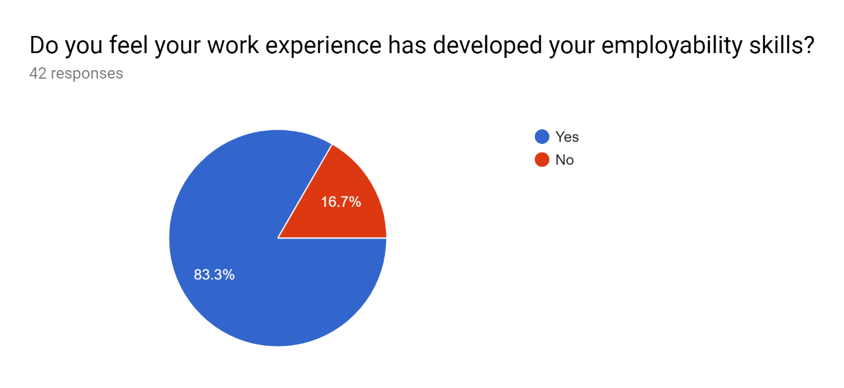
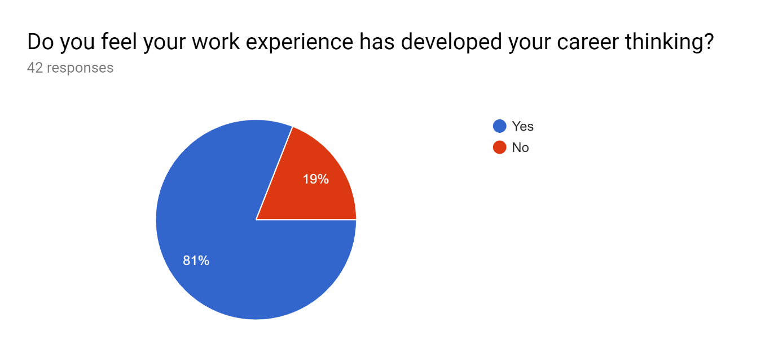
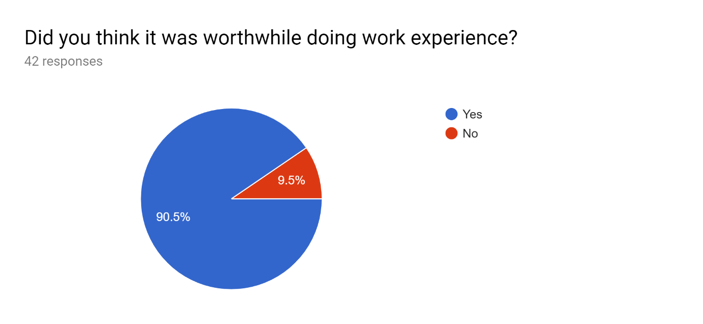
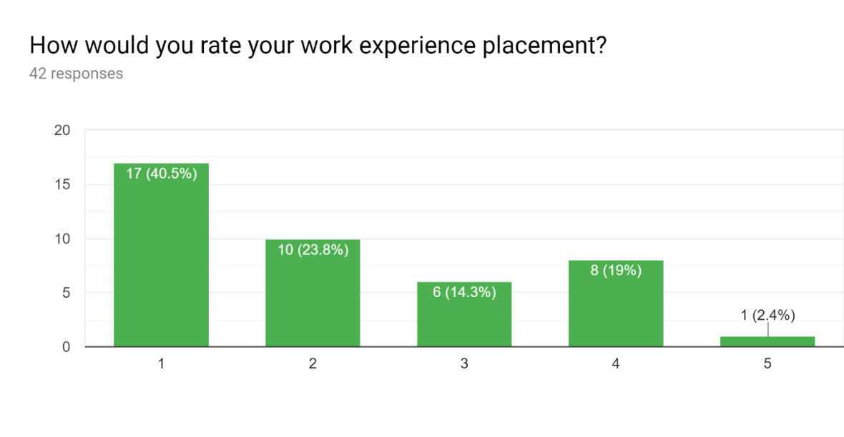
1 is excellent and 5 which was poor.
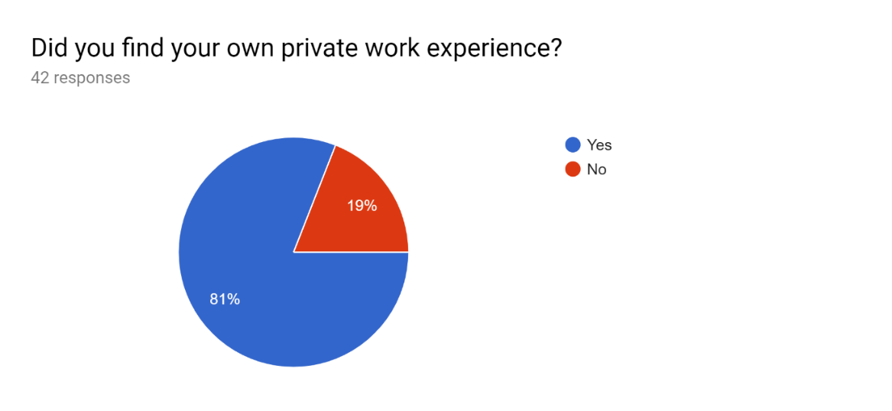

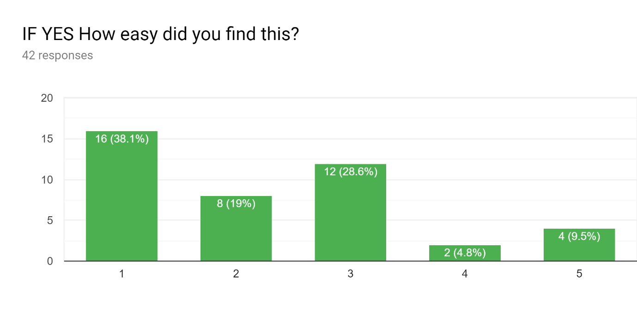
1 is easy and 5 is difficult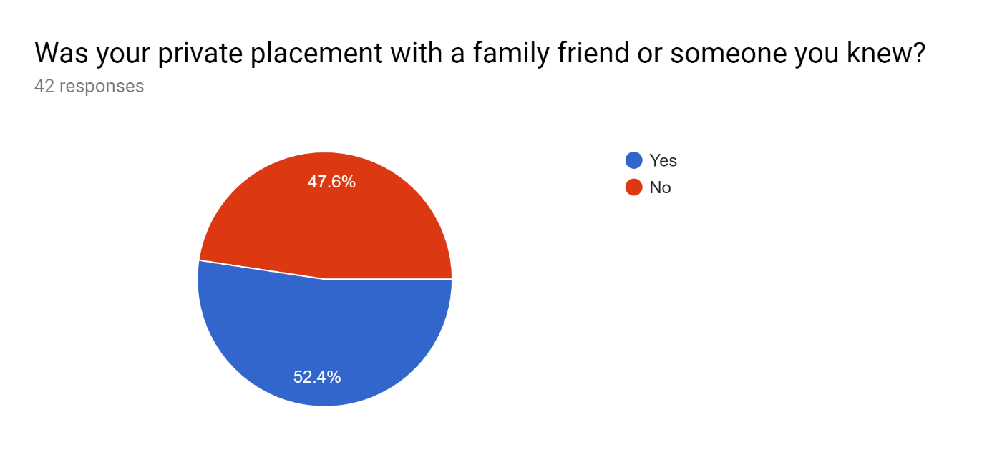
Any other comments:
- It was definitely worth while
- It was good but not relevant enough for my subject field. Also a week was too long, it got boring towards the end as there wasn’t that much to do. But over all, it was okay.
- Really enjoyed it, thought it was a great experience and very beneficial. However, possibly some people needed more support gaining their work experience than others as it was quite dependent on who you/your family knew.
- I had a lot of fun and got sponsorship at the end of it so couldn’t ask for much more
- It made me realise I didn't want a certain career path so was very useful.
- Was very informative

